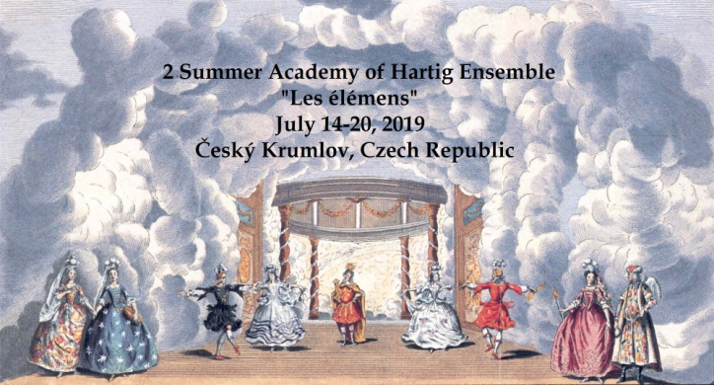

APPLICATION FORM (Preliminary)

Name: ........................................................................................................................
Address:........................................................................................................................
Contact (e-mail, phone)...............................................................................................

I would like to study mainly (circle or mark in other way your preferences):
1. Baroque dance My previous experience with this style:
a) beginner b) advanced c) very advanced d) ready for master-class

2. Renaissance dance
a) beginner b) advanced c) very advanced d) ready for master-class

3. Contre- and Country dances (17th and 18th Century)
a) no previous experience
b) I do have experience (you can write names of dances you have done in order for us to choose the best repertoire):

I would like to book accommodation in the Study Centre:
Yes No
(if yes, from what day until when, and if you already know the person, with whom you would like to share the room, please write his/her name):

Please fill in the form and send it back to us with e-mail (info@hartigensemble.cz) or with post to the address: Prof. Helena Kazárová, Ph.D., Vyšehrad 163, 381 01 Český Krumlov, Czech Republic, until the end of April 2019. After confirming your application, we will send you more detailed info and payment instructions. We communicate in English, German, Russian and basic French.

